HT600 Industrial-grade Handheld PDA Printer (Android 13)
High-performance 2D scanning | 70mm/s high-speed thermal printing | IP68 military-grade protection
Product Overview
HT600 is a ruggedized smart terminal specifically designed for high-intensity mobile work. It deeply integrates a 58mm thermal printer on the basis of traditional PDAs, supporting the printing of receipts, adhesive labels, and black labels, truly achieving a one-stop office experience of "scanning, processing, and issuing tickets" simultaneously.
Equipped with the Android 13 operating system and a 2.0GHz octa-core processor, this device ensures seamless processing of complex business logic. Its sturdy body boasts an IP68 rating (main unit) and can withstand a drop from a height of 1.5 meters, perfectly adapting to various harsh industrial environments. Equipped with an 8000mAh ultra-large capacity battery (optional) and 18W fast charging technology, it ensures ample power during long shifts, making it an ideal tool for logistics, retail, parking management, and on-site law enforcement.
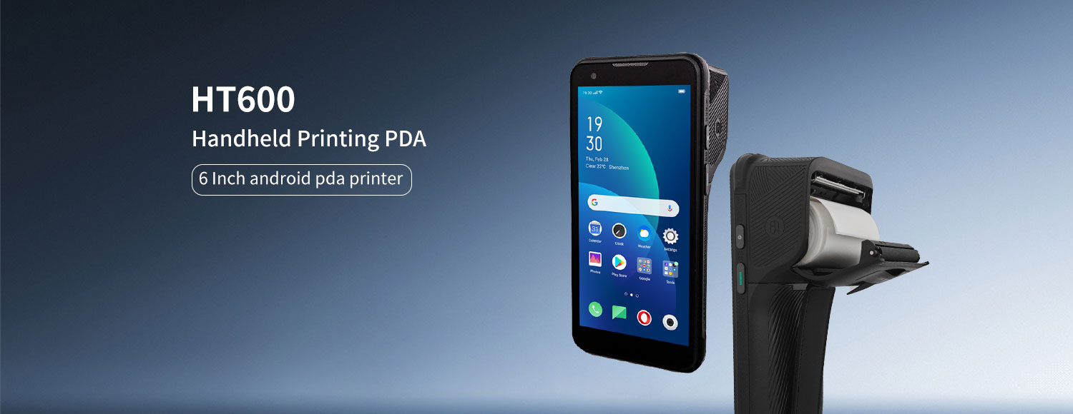
Summary of Core Technical Specifications
Category Key parameters
System / Performance: Android 13 / 8-core 2.0GHz / Up to 4GB+64GB
Printing function: 58mm thermal printing / 70mm/s high speed / support for label adhesive
Display screen 6.0" IPS (720P / 1080P) / Glove & Wet Touch
Scanning engine: Optional professional 2D hardware decoding (Honeywell N5703, etc.)
Battery capacity: Max 8000mAh / 18W fast charging / supports battery removal
Protection/Weight: IP68 (main unit) / 1.5m drop resistance / weight <350g
Recognition module: NFC, LF RFID (125K/134.2K)
Key Highlights
• Trinity, efficient operation:
Professional printing: Equipped with a built-in 57mm thermal printer, it boasts a printing speed of 70mm/s. It not only supports regular thermal paper but also supports adhesive label printing, meeting on-site labeling needs.
Accurate measurement: Equipped with internationally renowned 2D scanning engines such as Honeywell, it easily identifies various damaged, low-quality, or screen barcodes.
Multi-dimensional collection: Integrates NFC and low-frequency RFID (125K/134.2K).
• Robust performance and the latest system:
Running the latest Android 13 system, it offers higher security and stronger compatibility.
Equipped with an 8-core 2.0GHz processor, it can be optionally configured with up to 6GB+128GB storage combination, ensuring smooth processing of big data without any lag.
• Excellent industrial durability:
IP68 protection level: The main unit is completely dustproof and waterproof.
Drop-resistant design: Capable of withstanding multiple drop impacts from a height of 1.5 meters on all six sides.
24/7 Interaction: With a 6-inch IPS HD screen, it supports touch operation with water or wearing gloves, making it unafraid of rain or extreme weather.
• Long battery life and fast charging:
Offers a detachable battery option of 4000/8000mAh, with a standby time of up to 750 hours.
Supports 18W PD fast charging, fully recharging in less than 3 hours.
Ideal Applications
• Logistics and Warehouse Management: On-site receipt printing, shelf adhesive label replacement, and package scanning.
• Smart parking and traffic police enforcement: printing of violation parking tickets, on-site ticket processing, and vehicle license recognition.
• Retail and catering: mobile cashier, mobile ordering, promotional label printing, and takeout receipt printing.
• Public utility inspection: meter reading and payment for water and electricity, asset inventory and positioning.
Basic Information
processor | 8-core 2.0GHz high-performance processor
operating system | Android 13
Memory (RAM+ROM) | 3GB+32GB (optional: 4GB+64GB, 6G+128GB)
expand memory | Micro SD card, supports up to 256GB
display screen | 6-inch IPS display screen resolution 1440 × 720P, optional 2160X1080P
touch screen | Multi touch, can be operated with water on the screen or wearing gloves
rear camera | 1600W pixel high-definition camera, supporting autofocus and flash
front camera | 500W pixel camera (optional)
audio | Speaker (mono), microphone x 2, earpiece
prompt | Vibration prompt/LED prompt/audio prompt
keyboard | Silicone buttons: power button, volume+/- button, scan button x 2
booth | Nano SIM card x1/PSM card x1 (TF card)
battery | Rechargeable polymer battery (standard 7.7V/3.85V 4000/8000mAh)  Standby time>750 hours  Working hours>12 hours (depending on different working conditions)  Supports 18W fast charging and detachable battery  RTC power down retention for 5 minutes  Charging time<3 hours (using standard fast charging power adapter and data cable)
sensor | Light proximity sensor, distance sensor, gravity sensor  Optional: gyroscope, electronic compass
Communication transmission
USB port | Type-C USB x 1, Support OTG function
WLAN function | Dual band 2.4GHZ/5Ghz, supporting IEEE 802 a/b/g/n/ac protocols
Bluetooth | Supports BT 5.0, with a transmission distance of 5-10 meters
GPS | Supports GPS, Galileo, Glonass, Beidou
Wireless Wide Area Network | 2G: GSM (Mobile/Unicom), CDMA (Telecom)  3G: WCDMA (China Unicom), CDMA 2000 (China Telecom), TD-SCDMA (China Mobile)  4G: TD-LTE (Mobile), FDD-LTE (China Unicom, China Telecom)
thermal printing
Print speed | 70mm/s
Printing points | 384dots
Printing paper width | 57mm
Printing paper diameter | 35mm
Printing paper type | Support sticker printing, thermal paper printing, and black label printing
Optional configuration
2D scanning engine | Soft solution: MD5066/Honeywell N5703/CM60  Hard solution: N660
Support 2D barcode type | PDF417,Micro PDF417,GS1 Composite,Aztec Code,Data Matrix,QR Code,Micro QR Code,  MaxiCode,Hanxin Code,etc.
Optional configuration
NFC | Working frequency: 13.56MHz  Protocol standards: Supports ISO14443A/B and 15693 protocols
Low frequency RFID (optional) | Support, 125K (distance 3-5cm)/134.2K (distance 10-17cm)
Fingerprint recognition | Support the authentication of fingerprint modules by the Ministry of Public Security
environmental parameters
Operating Temperature | -20℃-60℃  *For safety reasons, please do not charge in low temperature environments
Storage temperature | -40 ℃ to 70 ℃
humidity | 5% RH -95% RH (no condensation)
drop specification | Within the operating temperature range, all 6 sides of the host can withstand a height of 1.5 meters (excluding the printing paper compartment)
Protection level | Host IP68 (excluding printing paper compartment)
Development support
development language | Java
Develop API | Android Standard Interface
structural parameters
Size (mm) | 169.5×83.2×18.2mm(The host does not include a print head)
weight | <350g (Depends on the device's functional configuration)
Equipment accessories
Standard configuration | Adapter, data cable, protective film, instruction manual, hand rope
optional | charging dock

